

**DATA STRUCTURES LAB**

**WEEK-4**

**Name**  : **ABHISHEK KUMAR JHA**

**Roll no** : **19R21A05C2**

**Date**  : **7/01/2021**

**QUEUE USING ARRAY:**

#include<stdio.h>

#define size 5

int Q[size],I,rear=-1,front=-1,x,ch;

void enqueue();

void dequeue();

void display();

int main()

{

printf("1.ENQUEUE\n2.DEQUEUE\n3.TRAVERSAL\n");

do

{

printf("\nEnter Choice\n");

scanf("%d",&ch);

switch(ch)

{

case 1:enqueue();break;

case 2:dequeue();break;

case 3:display();break;

}

}while(ch<=3);

}

void enqueue()

{

if(rear>=size-1)

printf("Queue Overflow\n");

else

{

printf("Enter data\n");

scanf("%d",&x);

rear++;

Q[rear]=x;

}

}

void dequeue()

{

if(front==rear)

printf("Queue Underflow: is Empty");

else

{

front++;

x=Q[front];

printf("%d is removed\n",x);

}

}

void display()

{

for(int i=front+1;i<=rear;i++)

printf("%d\t",Q[i]);

}

**OUTPUT:**

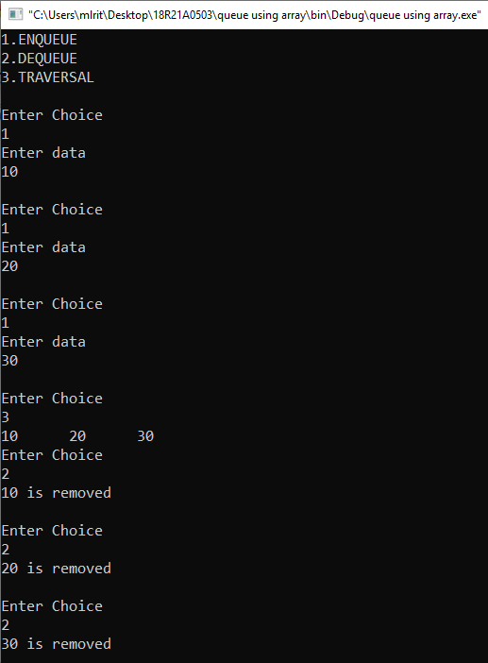

**QUEUE USING LINKED LIST:**

#include<stdio.h>

#include<stdlib.h>

struct node

{

int data;

struct node *next;

}*rear=NULL,*front=NULL,*n,*temp;

void enqueue();

void dequeue();

void display();

int ch;

int main()

{

printf("1.ENQUEUE\n2.DEQUEUE\n3.TRAVERSAL\n");

do

{

printf("\nEnter Choice\n");

scanf("%d",&ch);

switch(ch)

{

case 1:enqueue();break;

case 2:dequeue();break;

case 3:display();break;

}

}while(ch<=3);

}

void enqueue()

{

n=(struct node*)malloc(sizeof(struct node));

printf("Enter data\n");

scanf("%d",&n->data);

n->next=NULL;

if(rear==NULL)

{

rear=n;

front=n;

}

else

{

rear->next=n;

rear=n;

}

}

void dequeue()

{

if(front==NULL)

printf("Queue Underflow: is Empty");

else

{

temp=front;

front=front->next;

free(temp);

}

}

void display()

{

temp=front;

while(temp!=NULL)

{

printf("%d->",temp->data);

temp=temp->next;

}

}

**OUTPUT:**

